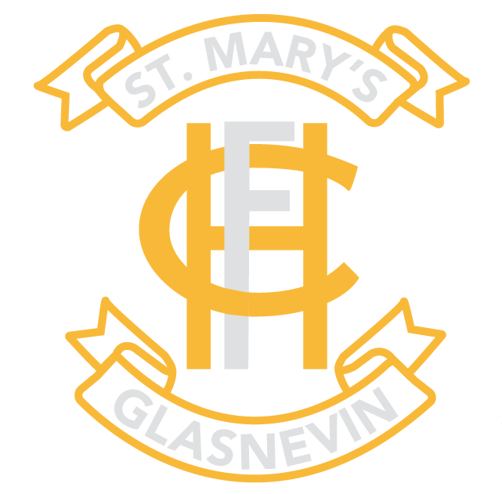
St Mary’s Secondary School
Glasnevin
Dublin 11
ANNUAL ADMISSION NOTICE
in respect of admissions to the 2023/2024 school year

A copy of the school’s Admission Policy and the Application Form for Admission for the 2023/2024 school year is available as follows: –
To download at: https://www.stmaryshfcglasnevin.com/parents/resources
On request: By emailing office@stmaryshfg.ie or writing to:
St Mary’s Secondary School Office
Holy Faith Convent
Old Finglas Road
Glasnevin
Dublin 11

Application and Decision Dates for admission to 1st Year for 2023/2024
The school will commence accepting applications for admission into 1st year 2023 / 2024 on | 3rd October 2022
The school shall cease accepting applications for admission on | 24th October 2022
The date by which applicants will be notified of the decision on their application is | 14th November 2022
The period within which applicants must confirm acceptance of an offer of admission is | 28th November 2022

Failure to accept an offer by 28th November 2022 may result in the offer being withdrawn.
Note: the school will consider and issue decisions on late applications in accordance with the school’s Admission Policy (available on the school website).
PART 2 – Admissions to the 2022 – 2023 School Year

Information regarding the admission process for the Intake Group for 1st year for the
2022 – 2023 school year

In respect of the 2022 – 2023 school year, the total number of applications for admission received by the school was 349.

Breakdown of places allocated for the 2021 – 2022 school year:
Number of places available: | 150
Number of applications received: | 349
Number of Offers made and accepted under each criteria

Criteria A – Sisters of students currently attending St Mary’s Secondary school | 23
Criteria B – Sisters of eligible past-pupils of St Mary’s Secondary School | 18
Criteria C – Daughters of eligible past-pupils of St Mary’s Secondary School | 21
Criteria D – Students in listed primary schools | 76
Criteria E – Other applicants | 12
Total number of offers made | 150
Number of names placed on the waiting list for the school year 2021 – 2022 | 199

